OFFICIAL COORDINATION REQUEST
FOR NON-ROUTINE OPERATIONS AND MAINTENANCE

COORDINATION TITLE- 17TDA15 AWS Concrete Demo
COORDINATION DATE- Apr 12, 2017
PROJECT- The Dalles Dam
RESPONSE DATE- April 13, 2017 (FPOM meeting)

Description of the problem
Concrete walls were poured for the 7’ valve room immediately adjacent to the Junction pool. However the walls were poured too high and require jackhammer removal to bring the top down to correct level. In addition rebar was insufficient height requiring additional rebar to be drilled into existing concrete. This work will require 2 night shifts of jackhammering and drilling. Work is proposed for April 15-18.
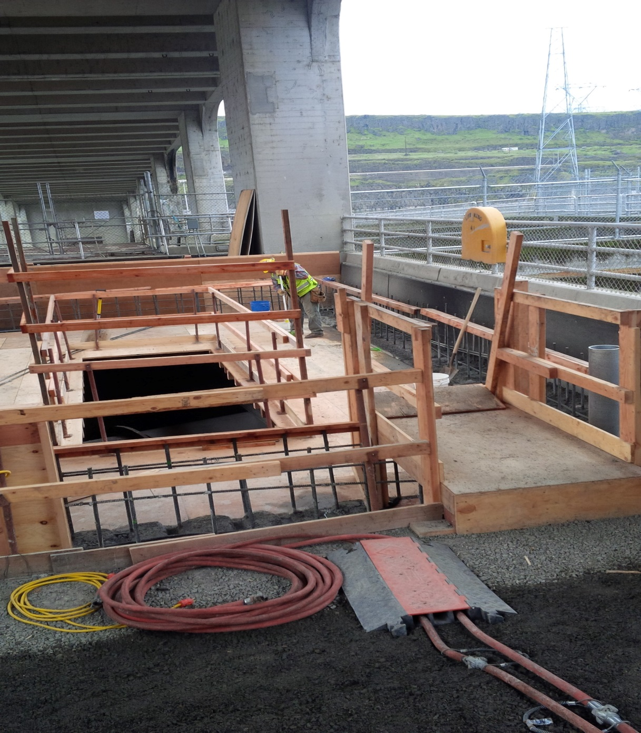

Type of outage required – None

Impact on facility operation (FPP deviations) -None

Impact on unit priority- None

Impact on forebay/tailwater operation - None

Impact on spill - None

Dates of impacts/repairs – April 15-18

Length of time for repairs – Expected 2 night shifts

Expected impacts on fish passage –
Upstream migrants – The ten year average for Chinook on April 15-18 ranged from 427 to 1122 per day. For steelhead the range was 26 – 33 per day. Currently passage at The Dalles is <10% of the ten year average for Chinook and ~30% for Steelhead this past week. Bonneville passage is <10% of ten year average for Chinook and ~80% of ten year average for Steelhead. Given the present low returns to date over Bonneville, expected daily passage for The Dalles on these dates would be 40 Chinook/day and 10/steelhead/day. Night counts for April were not found. However, comparing 2015 night counts for June Chinook, ~3.5% of daily passage is at night and ~12.5% for June Steelhead.
Summary statement – Expected is minimal due to very low fish numbers.

Downstream migrants – No impact due to location of work and distance from known passage routes.

Lamprey – No impacts expected; it is not normal lamprey passage period.

Bull Trout – impacts to Bull Trout are expected to be similar to other upstream migrating salmonids. Very few Bull Trout have been counted at TDA in the last 10 years.

Comments from agencies

Final coordination results

After Action update (After action statement stating what the effect of the action was on listed species. This statement could simply state that the MOC analysis was correct and the action went as expected, or it could explain how the actual action changed the expected effect (e.g., you didn’t need to close that AWS valve after all, so there was no impact of the action). List any actual mortality noted as a result of the action)

Please email or call with questions or concerns. Thank you,
Bob Cordie
Robert.P.Cordie@usace.army.mil
TDA Project Fisheries
541-506-7800

Erin Kovalchuk
NWP Operations Division Fishery Section
Columbia River Coordination Biologist
Erin.H.Kovalchuk@usace.army.mil

